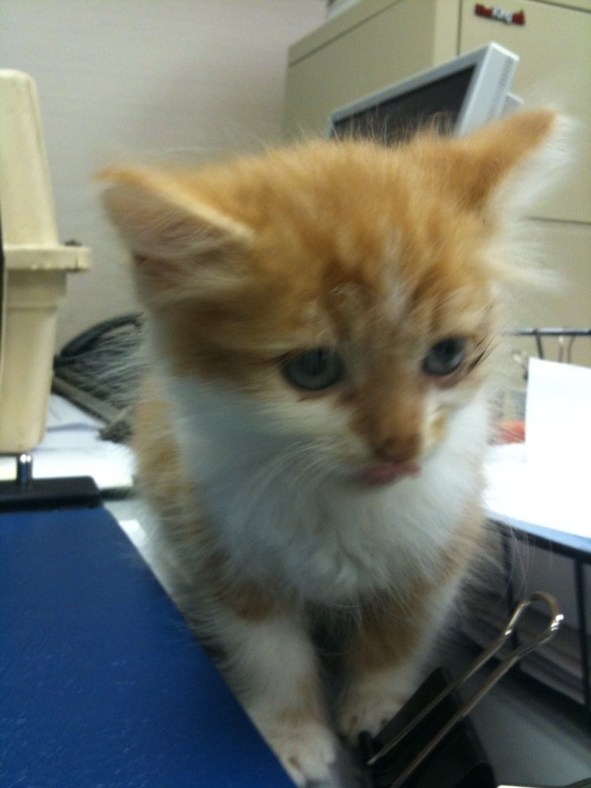
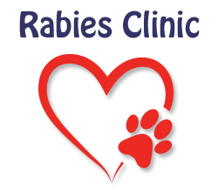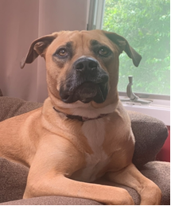

FREE RABIES CLINIC
TUESDAY, OCTOBER 7, 2025
6:30 – 7:30 PM

NORTHVALE DPW BUILDING
195 PARIS AVENUE

DOGS MUST BE ON LEASH
CATS MUST BE IN CARRIER

Any questions, call 201-767-3330, Ext. 219

