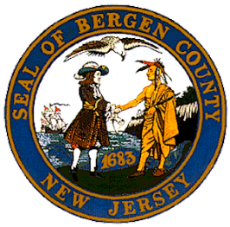

**BOROUGH OF NORTHVALE**

**2023 MOBILE SHREDDING EVENT**

**SATURDAY, SEPTEMBER 30, 2023**

**9:00 AM – 1:00 PM**

**BOROUGH HALL PARKING LOT**

**116 PARIS AVENUE**

**BERGEN COUNTY RESIDENTS ONLY**

